Name: Sai Dhanya Kollu

Roll number: 22BFA32068

# Course: Data Analytics with tableau

Assignment: 2

Assignment 2: Data Analytics with Tableau

Supermarket Sales Visualization

This assignment focuses on analyzing the historical sales data of a supermarket company operating in three different branches over a period of three months. Various Tableau visualizations were created to understand customer behavior, sales trends, and product performance.

The following charts were developed using Tableau:

# I.Donut Chart - Payment Distribution

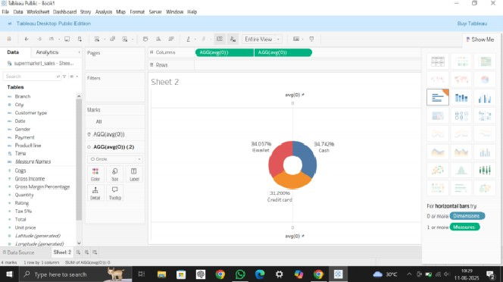

This Chart shows the distribution Of payment methods used by customers. It helps us understand which payment option (Cash, Credit Card, or E-Wallet) is most popular in the supermarket.

# 2.Area Chart Over Time

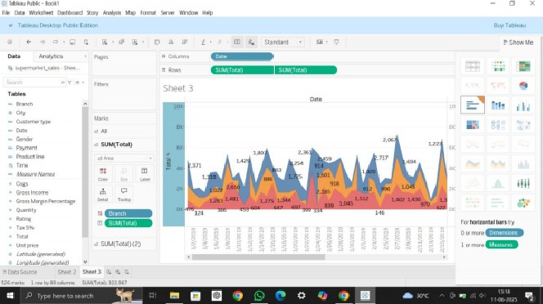

The area chart displays how total sales have changed over time. It helps to track sales performance across different days or months.

# Text Table by Product Line

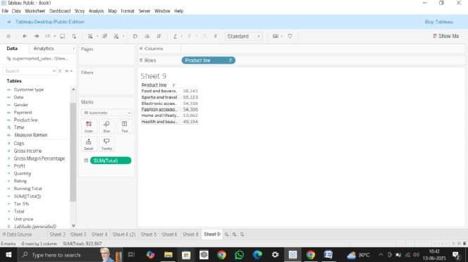

The text table shows the total sales for each product line. It provides exact numerical sales values, which helps in comparing the performance of different product categories.

# Highlighted Table Comparison by City and Product Line

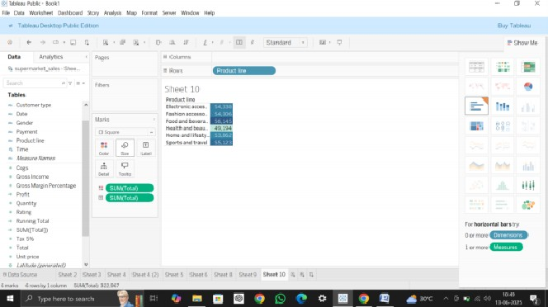

The highlighted table visually compares stiles across cities and product lines. The color highlights make it easy to see which products sold best in each city.

# Word Cloud - Product Line Frequency

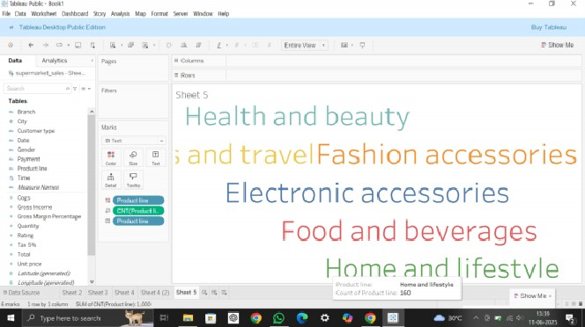

The word cloud represents the most frequent product lines purchased by customers. Larger words indicate more sales or higher frequency.

# Funnel Chart - Sales by Product Line

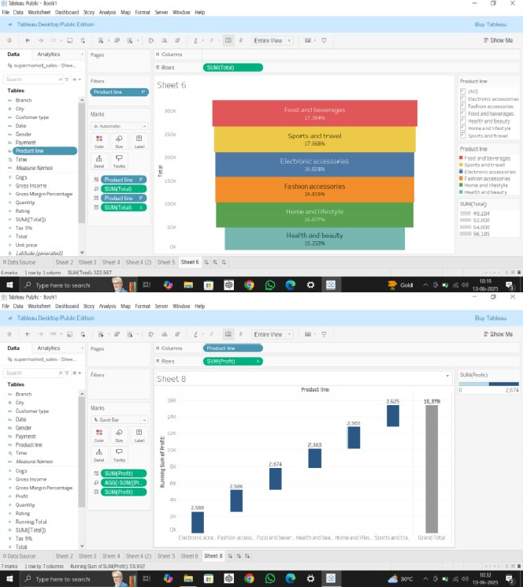

The funnel chart shows the step-by-step reduction in sales across different product lines. It helps to visualize which product categories have the highest or lowest sales,

7. Waterfall Chart - Sales Flow using Total

The waterfall Chart displays how sales (Total) increase or decrease across different product lines. It helps to understand the flow and changes in sales step by step.